Chapter 7 – Network Authentication
Bob just received a TCP packet from someone on the wire. Who did it come from, friend or foe? Does the source IP address assure him of the origin of the message, or could a bad guy have sent the packet, hiding behind an IP address that Bob believes is within his security perimeter? Maybe Bob doesn't even care about the IP address; rather, he wants to know on whose behalf the packet was sent. Was it Alice (a valid client) or a bad guy? The only way to tell is to have the sender of the packet prove his or her identity. The way to do this electronically is via careful use of encryption algorithms.
But even before Alice can send Bob an encrypted packet, the two of them have to agree on a key with which to encrypt that packet, and exchanging that initial key without any bad guy seeing you do it is tricky. This is what network authentication protocols are all about: proving (electronically) to the server the identity of the client (and often the other way around), as well as exchanging encryption keys in a protected fashion.
I've found that having a good conceptual grasp of network authentication can help instill a better intuition for developing and debugging secure distributed systems, so this chapter is all about what happens when a client and server authenticate with one another. There's not going to be much code; rather, I want to help you develop a more intuitive feel for the sort of work that's going on underneath the hood of the secure network communication subsystems covered in this book. This chapter first talks about NTLM (because it's so simple), then discusses Kerberos v5, and finally covers SPNEGO, a metaprotocol for negotiating the real protocol that a client and server will use. It also talks about the role of GSSAPI and SSPI in secure systems. If you've never been introduced to network authentication before, I hope you'll find this to be a fun (and challenging) chapter.

The NTLM Authentication Protocol
NTLM is the native authentication protocol on Windows NT 4, and is also supported on Windows 2000 for backward compatibility. NTLM stands for NT/LAN Manager because it is an extension of the protocol that was developed for Microsoft's LAN Manager product. It is a simple protocol and a virtually undocumented one (although much work has been done to reverse engineer it). I will share what I know about it based on looking at the Common Internet File System (CIFS) documentation and by performing my own network traces while debugging COM servers over the last few years.

Basic Challenge/Response Using Local Accounts
To understand client/server authentication using NTLM, it's best to start simple. Let's say that there is no centralized authority (in Windows parlance, no domain controllers) and that Alice is logged in to AlicesMachine using a local account defined there. Alice wants to access a secured resource on BobsMachine, and that resource is managed by a daemon process (the server application) running as Bob, perhaps in the form of an RPC or COM server. Alice is interactively logged on to AlicesMachine, and a process (the client application) running in her interactive logon session will physically make the request on her behalf. For this to work, Alice must first establish a logon session on BobsMachine, which means she must be authenticated across the network. In order for Alice to be authenticated on BobsMachine using a local account, the security database there must also contain an account named Alice with a matching password. Figure 7.1 shows the system prior to authentication.

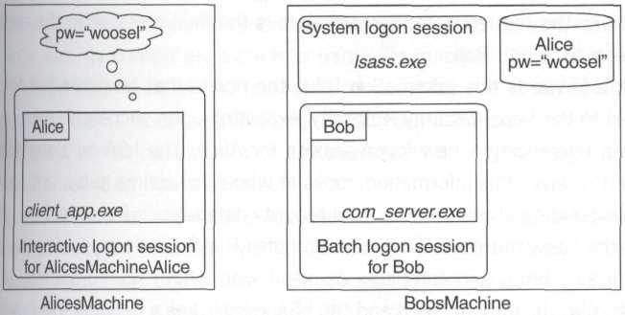
Figure 7.1. Ready for NTLM authentication using local accounts

Alice sends an initial message to Bob to get things going. This is known as the Negotiate message. (Alice is allowed to help negotiate a session key as well as other low-level details of the protocol, hence the name of the message.) When Bob receives this message, he's not sure who sent it, but whoever it was wants to initiate an authentication exchange, so Bob generates a 64-bit nonce and sends it back as the reply; this is known as the Challenge message. (Nonce is pronounced such that it rhymes with "once" and is simply a number that will be used only once; in this case, Bob won't ever use that same challenge nonce again.)
Alice now needs to take this nonce and use it to help prove her identity to Bob. She takes a one-way hash of her password and uses it as a cryptographic key to encrypt the nonce sent by Bob. (I'll refer to the result of this encryption as R.) She then sends her authority name, principal name, and R back to Bob. Known as the Authenticate message, this is the final message in the exchange between Alice and Bob.
Bob forwards this information (plus the nonce that he generated for Alice earlier) to the Local Security Authority, expecting upon success to receive back a token referencing a new logon session for Alice. The LSA on BobsMachine, when it receives this information, looks at who Alice claims to be, and looks for a corresponding account in the local security database on BobsMachine. It then takes the password it has for Alice, computes R independently (using the nonce specified by Bob), and compares its result with what Alice computed. If these match, Alice is authenticated and the LSA establishes a network logon session for her, and hands Bob back a token.
I'll mention right up front that if you're using COM or RPC (or even named pipes), you don't have to worry about performing this handshake – it's done under the covers by the corresponding communication subsystem. Even if you're programming simple sockets, although you'll have to be deliberate about shuttling the Negotiate, Challenge, and Authenticate messages back and forth, you won't have to worry about forming their contents; rather, you'll just delegate (as the other communication subsystems do) to a security service provider. This mechanism is discussed more in the section on SSPI.
Note that Alice's password was not sent across the wire. Thus the new logon session for Alice has no network credentials. Alice has now spent the single network hop allotted to her by the NTLM protocol, and although her logon session is valid on BobsMachine, it can go no further. If Bob impersonates Alice by putting her token on his thread and tries to contact JoesMachine, he won't be able to use Alice's credentials (this protects Alice, by the way).
Note also that Alice's token was not sent across the wire. Many developers I've spoken to have the impression that this is how authentication works. What would sending the contents of Alice's token prove? Anyone could replay those bits, and if that was all Bob relied on to prove her identity, he'd be in trouble.
Also, does Alice's token that was established on AlicesMachine make any sense whatsoever on BobsMachine? Remember that many of the authorization attributes in a security context are local to a particular machine (think aliases and privileges). So when the LSA builds a token on BobsMachine, it builds one that has meaning there. Because there are no domain controllers involved, the resulting token will be populated with any aliases and privileges assigned to the Alice local account on BobsMachine.
Figure 7.2 illustrates the handshake just described. Notice that there are ultimately three logon sessions involved: Alice's interactive logon session, where her request originated; Bob's daemon logon session (to make this concrete, I used a batch logon, but a service logon is also common); and finally, Alice's network logon session on BobsMachine, which acts as a sort of proxy for her interactive logon session back on AlicesMachine. Bob must juggle his own security context and those of any clients making authenticated requests (Alice, in this case) via selective use of impersonation, as discussed in Chapter 4.

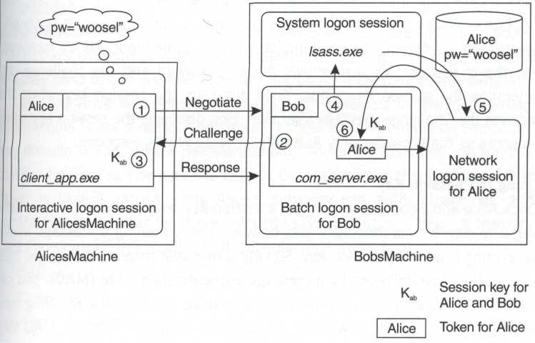
Figure 7.2 Basic NTLM handshake (using local accounts)

If you've enabled auditing of logon and logoff events on BobsMachine, and if you look in the event viewer, you'll notice a new success audit indicating that Alice was just authenticated and has established a network logon session.

Session Key Discovery
So Alice has proved her identity to Bob. What now? The whole reason she went through all that hassle was to make authenticated requests to Bob (perhaps for sensitive data to which only she has access). Now that Alice and Bob are connected, and Alice has a logon session on BobsMachine, how does Alice continue to assure Bob that she is still the same principal? How does Bob discern that a given network packet really came from Alice, as opposed to some malicious router on the network that wants to hijack Alice's logon session on Bob's machine? The solution, once again, lies in selective use of cryptography.
Originally, Alice used her master key to prove her identity to Bob; this is her password hash. After the authentication handshake, Alice and Bob both discover a session key – technically, the security service provider (SSP) on either side manages this key (more details later) – which Alice can optionally use to authenticate data that she sends to Bob. Just as the response is a one-way function of Alice's password and Bob's challenge, so too the session key is discovered via a different one-way function with the same input: Alice's password and the challenge. Whoever knows Alice's password and the challenge can determine the session key. Thus, Alice discovers the session key when she receives the Challenge message from Bob. Bob discovers the session key when he contacts the Local Security Authority to verify Alice's response.

Using the Session Key
Once Alice and Bob have exchanged a session key, they can use it in two basic encrypting it with the session key. Signing a message means sending the message in the clear, followed by a message authentication code (MAC). You can think of a MAC as a one-way hash of the payload in which the resulting hash value has been encrypted with the session key. Who can form the MAC for a given message? Only someone who knows the session key. Who can modify a MAC-protected payload? Only someone who knows the session key (because the MAC would need to be regenerated based on a hash of the new payload).
When Bob receives a message (including its MAC) that comes in over Alice's network connection, he can verify that Alice was the one who generated the message by independently calculating the MAC and comparing it with the one sent with the message. After this, Bob knows two things: Alice sent the message, and the message wasn't tampered with on the wire. Usually the message header includes a sequence number (the header is protected by the MAC as well), so Bob can also discover if Alice's messages have been reordered on the wire. Note that sealing can be much more expensive than signing, at least in terms of CPU cycles; the network packets aren't noticeably larger after encryption.
Each communication subsystem provides its own options for leveraging the session key. RPC and COM, for instance, allow the client to choose (programmatically, at each method call) how much to leverage the session key, whereas there is no such programmatic control over a named pipe.

Pass-Through Authentication Using Domain Accounts
So far we've seen that using a local account, Alice can prove her identity to Bob and establish a network logon session on BobsMachine. We've also seen that during the authentication exchange, Alice and Bob both independently discover a session key that can be used to authenticate (via signing or sealing) the actual data they send to one another. Now let's introduce a centralized authority.
Let's say Alice and BobsMachine are both principals in the Foo domain. BobsMachine is not a domain controller; it's just a normal machine whose primary domain is Foo. Alice's password is only known by Alice and the security database for Foo, so how can the LSA on BobsMachine authenticate her? The answer is that it cannot. Only Alice's authority can authenticate her, and BobsMachine must trust what her authority says (by virtue of being a member of the Foo domain, this implies that BobsMachine trusts Foo).
Physically, the handshake looks exactly the same as it did before: Negotiate, Challenge, Authenticate. However, when Bob's SSP calls into the LSA on BobsMachine, passing it the nonce plus Alice's name and her response, the LSA simply passes this information up to one of the domain controllers in its primary domain (Foo). Foo notes that the client has purported that her authority is Foo and her principal name is Alice, and thus looks up Alice's account, calculates R independently based on the password material stored in the security database, and verifies Alice's identity. It then sends confirmation, plus a list of global authorization attributes (groups) for Alice back to the LSA on BobsMachine, which takes those authorization attributes, combines them with local authorization attributes (aliases and privileges), and establishes a network logon session plus a token to hand back to Bob's SSP The obvious question is: how does Bob's SSP discover the session key, which is essentially owf (password, challenge)? Alice discovers the session key (as before) during the Challenge leg, and Foo discovers it by combining the nonce from Bob with the password material stored in the security database. Foo must somehow communicate this session key to BobsMachine without it being discovered by a bad guy, which means that it needs to be encrypted.
Chapter 1 made a really big deal of pointing out that machines in a domain are principals in that domain. This is where that relationship is really important. Because BobsMachine is a principal in the Foo domain, it has a machine account in that domain with a password. When BobsMachine boots, one of the system's duties on startup is to perform an authentication handshake with a domain controller in its primary domain. (Although the physical mechanism is a bit different, conceptually the handshake between BobsMachine and Foo is similar to the three-way handshake shown earlier using local accounts.) So by the time Alice comes along, BobsMachine has already exchanged a session key with Foo and thus has the potential to send and receive signed and sealed messages from Foo. The session key for Alice and Bob is therefore sent encrypted with the session key established earlier between BobsMachine and Foo. So even in this case, Bob's SSP receives not only Alice's token from the LSA, but also a session key used to authenticate data sent to and from Alice. Figure 7.3 demonstrates this mechanism.

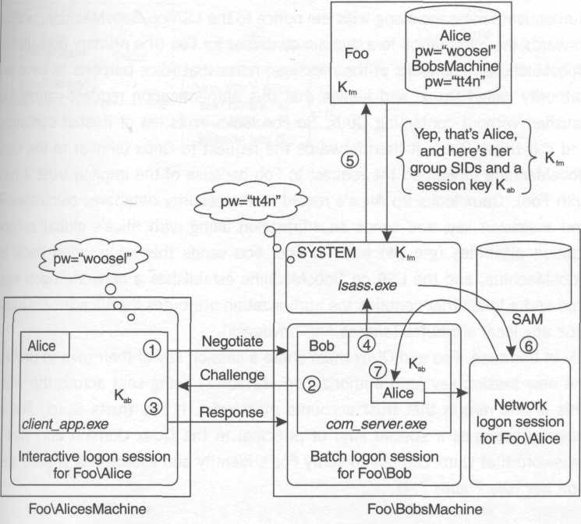
Figure 7.3 NTLM pass-through authentication

Cross-Domain Authentication
What happens if Alice and BobsMachine are in different domains? You can probably see where this is leading. Let's say that Alice is a principal in Quux, and BobsMachine is a principal in Foo. Alice wants to access a secured resource on BobsMachine and thus must establish a logon session there. To do this, she must be authenticated, and so once again she and Bob exchange the Negotiate, Challenge, and Authenticate messages as before. Bob hands the results of the Authenticate message along with the nonce to the LSA on BobsMachine, which forwards the information to a domain controller for Foo (the primary domain for BobsMachine). Foo looks at the message, notes that Alice purports to have an authority called Quux, and knows that this authentication request cannot be satisfied without contacting Quux. So Foo looks in its list of trusted domains, and if it trusts Quux, it then forwards the request to Quux (similar to the way BobsMachine forwarded the request to Foo because of the implicit trust it has with Foo). Quux looks up Alice's record in the security database, calculates R and a session key, and sends an affirmation along with Alice's global authorization attributes (groups) back to Foo. Foo sends this information back to BobsMachine, and the LSA on BobsMachine establishes a network logon session and a token that contains the authorization attributes for Alice (from Quux) plus any local attributes (aliases and privileges).
In this case, Foo and Quux must share a session key of their own to protect the new session key (and authorization attributes) being sent across the wire. This is one reason that trust accounts must exist. If Foo trusts Quux, Foo in essence becomes a special kind of principal in the Quux domain and has a password that Quux can use to verify Foo's identity and establish a shared session key (see Figure 7.4).

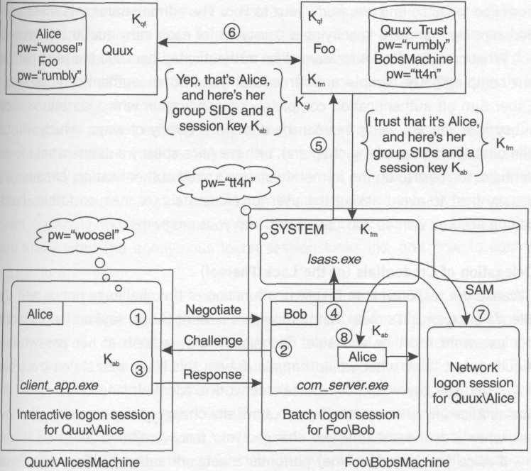
Figure 7.4 Cross-domain NTLM authentication

The Path of Trust
Note that in all three of these scenarios, in order for Alice to establish a logon session on BobsMachine there has to be a path of trust directed from BobsMachine (the target machine) to the authority for Alice (the client). In the first case, the trust path was short: BobsMachine trusts its own LSA by definition (the LSA is part of the trusted computing base), and with a local account, the local authority is the authority that vouches for the principal. In the second case, BobsMachine trusts its primary domain (Foo). In the third case, BobsMachine trusts Foo, and Foo trusts Quux.
It's interesting to note that whereas BobsMachine sports a transitive trust relationship with Foo (that is, BobsMachine trusts Foo and all the domains that Foo trusts – Quux was one example), Foo's trust relationship with Quux is not transitive. Cross-domain trusts are never transitive under NT 4; because so much of NTLM is undocumented, it's not clear whether this is a limitation of the protocol or simply a built-in throttle to avoid network congestion and brittleness. So for a Windows NT 4-based system with four domains that all trust one another, there must be 12 trust relationships (see Figure 1.4 in Chapter 1).
Remember, if Foo and Quux trust each other, that's two trust relationships: one from Foo to Quux, and one from Quux to Foo. The administrator sets these relationships up manually, specifying a password for each individual trust account. What can you do if Alice cannot be authenticated because the trust path is not complete? The simple answer is that you cannot authenticate as Alice. Either turn off authentication completely (depending on which communication subsystem you are using this can be done in a variety of ways, which will be demonstrated in upcoming chapters), or have Alice specify a different set of credentials. It's best to do the former if you don't need authentication, because it's usually best to avoid asking the user for credentials (or, heaven forbid, hard-coding account names and passwords into your programs).

Delegation of Credentials (or the Lack Thereof)
Because the response R in NTLM is a function of the challenge nonce and the client's password, it's clear that to represent a client (Alice, say) on the network, her password must be available. Technically, only a hash of her password is required, but think what would happen if even this hash was stolen by a bad guy: That bad guy would own Alice's network credentials and could masquerade as Alice anywhere on the network until she changes her password. (Be honest, when was the last time you changed your password?)
If Alice (on AlicesMachine) performs a network authentication with BobsMachine, thus establishing a network logon session there, that network logon session does not possess Alice's network credentials. Therefore, the daemon process on BobsMachine servicing her request has no possible way to masquerade as Alice on the network, even if Alice wanted to allow that. If Alice wants to delegate her credentials to the daemon on BobsMachine, she'd have to communicate her password hash to him. Imagine the implications of this! It's as if she had given her password away; there is no limit in time or space on what that daemon can do with Alice's credentials. Thus NTLM does not support delegation of credentials. The protocol just wasn't designed with this in mind. If the daemon attempts to use Alice's logon session to make NTLM-authenticated network requests, it'll end up using a NULL session instead. Speaking of NULL sessions . . .

NULL Sessions and Anonymity
Imagine that you wanted to have a system in which some clients were authenticated and others were not. To perform role- or object-centric access control, you'd have to have security contexts for both types of clients, plus a way of distinguishing the difference between the two that you could leverage directly in your access control scheme.
A security context implies a token, and a token implies a logon session. So in order to represent authenticated and anonymous clients polymorphically, you need to be able to establish a logon session for an anonymous client. That may sound bizarre, but it is possible on Windows and is actually very convenient for application developers. With that said, it's critically important that you know what the anonymous logon session looks like and how to control access to it.
The anonymous logon session is often referred to as a NULL session (the anonymous network connection is also sometimes referred to as a NULL session, which can cause some confusion), and the NTLM authentication protocol is one way of setting this up. If you look at a packet trace for the NTLM exchange between the client and server during NULL session establishment, you'll still see the Negotiate, Challenge, and Response messages, although they'll be quite empty of most content. If it seems strange to bother with a three-leg handshake even though we aren't truly authenticating, well, you aren't the only one who finds this strange. My guess is that it has to do with NTLM's early ties to the Server Message Block (SMB) protocol, which is the protocol that the Windows file system redirector uses. If you compare this with DCE RPC (and therefore COM, whose foundations lie on DCE RPC), DCE RPC has a provision for unauthenticated clients; it simply doesn't bother with the authentication handshake at all if the client doesn't want to be authenticated.
If you aren't using NTLM (perhaps you're using Kerberos), the way you represent an unauthenticated client is by not sending any authentication information to the server at all. In this case, no logon session will be established at all, which means you can't use your normal access-checking code paths because you won't have a token for the client. Windows 2000 provides a function that can help if you find this to be a problem:

BOOL ImpersonateAnonymousToken(
HANDLE ThreadHandle); // in

This function is exported from advapi32 .dll and is declared in winbase.h, but for some reason (perhaps an oversight), this useful function is not documented on MSDN as of this writing, so caveat emptor. The idea here is that if you don't have a security context for the client at all, you can use this special anonymous security context instead.
Calling this function produces a token that references a hardwired logon session known as the anonymous logon session (like the System logon session, it also has a hardcoded identifier defined as anonymous_logon_luid in winnt.h). The resulting token after calling this function is shown in Figure 7.5. Using an NTLM exchange to produce a NULL logon session results in a token that looks similar, with the addition of the Network SID indicating that this is a network logon session (thus the asterisk next to it in the figure).

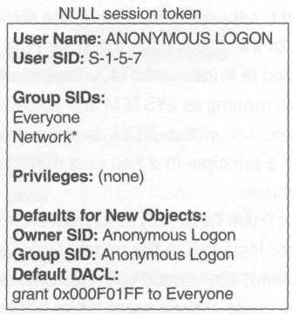
Figure 7.5 A token for the NULL session

So how does one control access to the anonymous logon session? It includes the Everyone SID (as all tokens do); thus, if you grant access to Everyone, this clearly includes the anonymous logon session. (Please note that distributed systems will often provide special additional access checks for anonymous users; for instance, in the file system, just granting access to Everyone on a network share isn't quite sufficient to allow NULL sessions to access them. Discussions of how various communication subsystems deal with this are provided in the following chapters.) If you're using an object-centric access control model, one way of protecting yourself is to explicitly deny the anonymous logon SID (S-1-5-7). But in Windows 2000 (and most versions of Windows NT 4) there is an easier way. Read on.
Because the Windows NT 4 ACL editor really couldn't deal with negative ACEs in any reasonable fashion, in Service Pack 3 Microsoft added a new well-known SID called Authenticated Users (S-1-5-11). This SID is present as an authorization attribute in all tokens except those for the anonymous logon session, and allows you to control anonymous access with purely positive ACEs. To do this, instead of granting access to Everyone, grant access only to Authenticated Users.
So far, this chapter has discussed at length the way NULL sessions work, the resulting anonymous logon session, and how to perform access control with NULL sessions in mind. What has not been discussed is how a client chooses to use a NULL session in the first place.
You won't normally see an NTLM NULL session exchange unless the client actually has no network credentials at all. My rule of thumb is that the system will attempt to use a NULL session if the client has NULL network credentials. When do you have NULL network credentials? The obvious case is when your security context is that of the anonymous logon session. A less obvious case is the SYSTEM logon session in Windows NT 4, where machines are not truly first-class principals. If you're running as SYSTEM and you attempt to perform NTLM authentication, you'll end up with a NULL session every time. On Windows 2000, if the machine is a principal in a Kerberos domain, it can be represented with its Kerberos credentials.
Another case in which you have NULL network credentials is an NTLM network logon session. If, for instance, in the middle tier of a three-tier system, you impersonate a remote client, your thread will enter a security context with NULL network credentials (the client already spent his or her one network hop getting to the middle tier). If you try to use the client's logon session to communicate with the back tier, the best you'll do is establish a NULL session.

Guests and Anonymity
NULL sessions are only used when the client is using a logon session with NULL network credentials. What if the client actually has credentials on his or her system, but the server has no trust path to the client's authority? Or what if the client is using some local account that the server has never heard of before? In this case, even using NTLM, a NULL session will not be established; rather, authentication will simply fail.
In order to group all these "unknown clients with credentials" into a common category and treat them polymorphically, each Windows machine has a well-known account named Guest. The SID is composed of the machine/ domain identifier followed by a well-known RID:

DOMAIN_USER_RID_GUEST

The Guest account is normally disabled by default, but by enabling it and setting the password to an empty string (the default value), all clients with unknown authorities (or local accounts with no match on the server) will obtain a logon session under the guise of Guest on that machine. Note that this is a per-machine setting. (Enabling the Guest account on a domain controller only affects the domain controller; it doesn't have any special affect on the machines in the domain.) Figure 7.6 shows the resulting token that the server obtains.

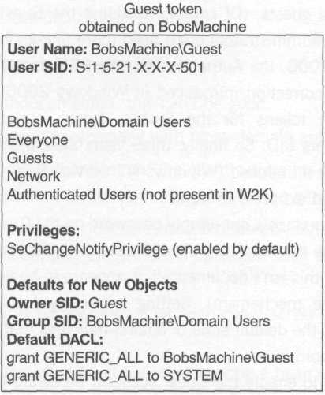
Figure 7.6. A token for a guest

Note that I've included the Authenticated Users SID with a note in Figure 7.6. In Windows NT 4, for some reason guests had this SID in their token. Thus, if the Guest account was enabled, in order to correctly block access to all anonymous users (including guests), an administrator couldn't simply eschew the Everyone SID in favor of Authenticated Users because this would still allow guests to leak through. The administrator had to explicitly add a negative ACE to deny access to guests. (Of course, disabling the Guest account blocks all guest logons, but administrators often need more fine-grained control.)
In Windows 2000, the Authenticated Users SID is not present in a Guest token. The other correction introduced in Windows 2000 (mentioned in footnote 11) is that tokens for the System logon session now include the Authenticated Users SID. So finally, three years after the Authenticated Users SID was originally introduced (Windows NT Service Pack 3), it actually works the way you would expect it to work!
It is possible to place a non-empty password on the Guest account for a particular machine. In this case, the client's password must match the one you've chosen (although this isn't documented, it appears to be verified via the NTLM challenge/response mechanism). Setting an empty password on the Guest account (which is the default state of affairs) indicates that you don't care what the client's password is.
If you choose to enable the Guest account, be aware that it may not work as smoothly as you might think. For instance, if an unknown client (Alice) happens to be using an account whose name matches that of a local account on your machine ("Alice"), the system will attempt to authenticate that user using the local account (not Guest), and if the passwords don't match, authentication will fail. One way of getting around this is to have the client specifically use the user name "Guest" when authenticating, which avoids this problem but requires a bit of extra work in the client application (it's doubtful that the client is actually logged in as "Guest" on the client machine, so the client-side application code needs to specify alternate credentials programmatically in most cases). Different ways of providing alternate credentials to various communication subsystems are described in the following chapters.

Benefits and Drawbacks of NTLM
NTLM has the following benefits:

- It is built in to Windows 2000 and earlier versions of Windows NT.
- It is simple to understand (at least conceptually).
- Authentication results in the exchange of a session key.
- It supports the use of centralized authorities.
- It supports cross-domain authentication.

NTLM has the following drawbacks:

- It is mostly undocumented; this can't be good.
- It can be expensive, especially with cross-domain authentication.
- It uses one-way authentication; the client proves his or her identity to the server, but never receives confirmation of the server's identity.
- The client and server must be connected to each other (thus, the protocol does not support disconnected operation such as authentication of MSMQ messages).
- Trust links must be operational for each client/server authentication handshake to succeed.
- The operating system must constantly cache a hash of the client's password in order to authenticate; if this hash is discovered by evil code lurking in the TCB, the client's network credentials have effectively been stolen.
- NTLM does not support cross-domain transitive trust relationships, making administration difficult.
- It does not support delegation of credentials.

The Kerberos v5 Authentication Protocol
Kerberos was originally introduced by the folks working on Project Athena at MIT back in the 1980s. Since then, Kerberos has undergone lots of revisions, but version 4 was the first version that was really fit for public consumption. The most recent version (v5) is documented in RFC 1510 and is the version of Kerberos that is implemented in Windows 2000. Compared with NTLM, Kerberos is much more sophisticated (and much more secure). It's also quite refreshing to study because it is fully documented; unlike the previous description of NTLM, there's no guesswork here.

The Three Subprotocols
Kerberos is named after the mythical three-headed dog that guards the entrance to Hell. I like to think of the three heads as representing the three subprotocols of Kerberos. One of the beauties of this protocol is that the cost of authentication is effectively amortized across these three subprotocols, and each subprotocol is lazily performed on an as-needed basis.
Unlike NTLM, Kerberos requires a centralized authority (traditionally known as a KDC or Key Distribution Center). Each principal in a Kerberos realm has a master key, and the KDC itself also has a master key. A realm represents the scope of one authority (just like a domain does in Windows). Each master key is derived from a password.

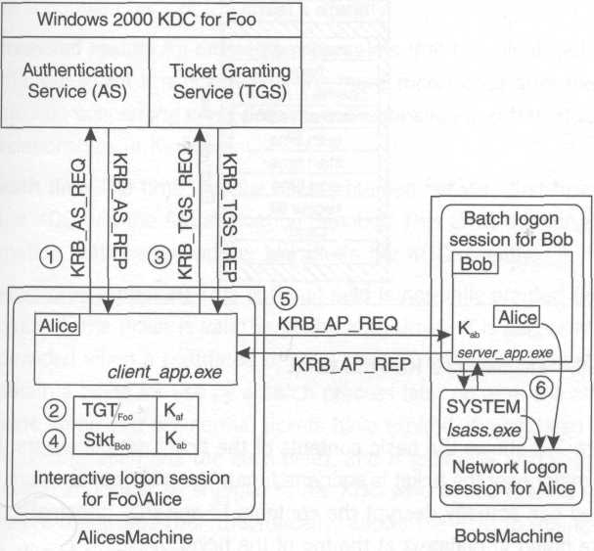
Figure 7.7 The three subprotocols of Kerberos v5

Figure 7.7 shows the three subprotocols, their names, and the order in which they are executed. In the figure, Alice is the client, Bob is the server with whom she is authenticating, and Foo is Alice and Bob's authority, implemented by a Windows 2000 domain controller, which acts as a Kerberos KDC. In between the subprotocols, the client caches state that helps avoid unnecessary network round-trips; each entry in the cache consists of a Kerberos ticket plus a session key for use with that ticket.

Kerberos Tickets
For the last couple of years around Halloween, my wife and I have been taking our kids to a little pumpkin patch down on the corner close to our home. It's obligatory that my sons get to ride the ponies, jump in the bounce house, and ride on the kiddy Ferris wheel. The way this particular amusement park works is that you have to buy different colored tickets for each ride. If you don't have the right ticket, you don't get to ride.
Tickets in Kerberos are much like this; they are labeled with a target principal, and they can only be used to help you authenticate with that one particular principal. If Alice (a principal in the Foo realm) wants to authenticate with Bob and Mary (also principals in Foo), she'll actually need three tickets, not just two, because she'll first need to get a ticket for Foo before Foo will be willing to give her tickets for Bob and Mary. Foo is playing two roles here: It provides the Kerberos Authentication Service (AS) and the Kerberos Ticket Granting Service (TGS). The former is where Alice goes to get her very first ticket (the ticket for Foo), and the latter is where Alice goes to get tickets for Bob and Mary. These services are both provided by the KDC. What's nice about a ticket is that once you have one, you can continue to use it to establish new authenticated connections until the ticket expires (expiration times are usually eight to ten hours, the duration of a typical workday).

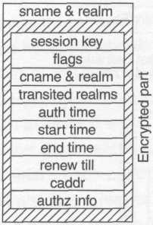
Figure 7.8 Anatomy of a Kerberos ticket

Figure 7.8 shows the basic contents of the ticket data structure. Note that the vast majority of the ticket is encrypted; only the principal to whom the ticket is targeted can actually decrypt the contents, and that principal's name and realm are noted in plaintext at the top of the ticket. Here's what each field means, briefly:

- sname & realm The target principal's name and realm.
- session key The all-important session key. Remember that after Alice and Bob authenticate, they each need to end up holding a session key to authenticate the data they send to one another. This is the server's copy of the key. The client receives her copy of the key when she receives the ticket from the KDC.
- flags These flags indicate any special circumstances under which the ticket was obtained, as well as any special ways the ticket may be used. I'll talk about a few of these options as I go through the protocol.
- cname & realm The client principal's name and realm, which is used as a double check of the client's identity.
- transited realms An ordered list of realms that the client had to visit in order to get this ticket. This will make more sense after the discussion concerning cross-domain authentication and transitive trust relationships in Kerberos.
- auth time The time that the client obtained her very first ticket from the KDC (via the Authentication Service). This gives the server confirmation that she proved her identity to her KDC recently.
- start time (optional) This optional field is normally omitted (when omitted, the ticket is valid as of the auth time). It is generally only provided when a postdated ticket is used. This allows a client to obtain a ticket for use by a batch process later on after the client has gone home and her normal tickets have expired. A postdated ticket is flagged as such (via the flags field), and is generally also flagged as invalid and must be shipped to the KDC who issued it to be validated before it is used. This (theoretically) allows the KDC to maintain a hotlist of tickets that are known to be stolen.
- end time The time after which the ticket becomes invalid and should be rejected by servers. Forcing tickets to expire puts limits on how much time an attacker has to get to a safe location in order to use a stolen ticket.
- renew till (optional) Similar to a postdated ticket, a renewable ticket allows a client application to use a ticket for a very long time without requiring the client principal to provide her master key to get a new ticket every eight hours. The ticket is actually renewed each time it's about to expire, which results in a fresh ticket for the client and a fresh session key. As discussed later, this also keeps the authorization attributes stored in the ticket from growing overly stale.
- caddr (optional) An optional list of client host addresses (for instance, IP addresses on a TCP/IP network) that indicates the machines from which the server should expect requests to originate. Network addresses are relatively easy to spoof, so this is only here to make it a bit more difficult for a bad guy to steal a ticket and a session key and use it from a safe location.
- authz info (optional) This field is where any authorization attributes (for Windows, this means group SIDs) are stored.

The KDC confers ownership of a ticket to a legitimate client by discreetly passing a copy of the session key to the client. No server will accept a ticket unless the client can prove that he or she knows the associated session key.

The First Subprotocol: KRB_AS_REQ/REP
When Alice first wants to participate in Kerberos (at the beginning of her workday, for instance), she must prove her identity to one of the KDCs in her realm. The way she does this is somewhat indirect: she requests a ticket by sending the KRB_AS_REQ message (for Authentication Service Request) to the KDC. The KDC sends back a KRB_AS_REP (Authentication Service Reply). Figure 7.9 shows the contents of the request and reply.

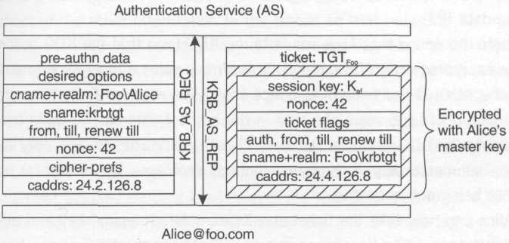
Figure 7.9 The KRB_AS_REQ and KRB_AS_REP messages

The request includes the client's purported principal name and realm as well as the server's name; in this case, this is the client's authority. The request also includes a number of options (the requested start and end times, the requested network addresses from which the ticket may be used, whether the ticket should be renewable, and so on). The key thing to note is that when the KDC receives this request, it doesn't have proof of Alice's identity. As far as the KDC is concerned, it just received a request from a random source that purports to be Alice. And this is all right; read on.
The reply that comes back to Alice contains a ticket targeted at Alice's authority, but remember that a ticket is not enough – the client also needs the corresponding session key associated with the ticket. Thus the KRB_AS_REP message also contains the session key as well as confirmation of the target principal and the options that were granted in the ticket. (Recall that Alice cannot see 90 percent of the ticket's contents; it's encrypted so that only the target principal can unlock it.) All this extra information that accompanies the ticket is encrypted with Alice's master key (which the KDC knows, by definition of being Alice's authority). So besides the KDC, only Alice can possibly use the ticket, because only she can decrypt the session key that comes back via the KRB_AS_REP message.
Allowing any random node on the network to send messages to the KDC and receive replies encrypted with a principal's master key opens the system up somewhat to an attacker, because the KDC will always reply with a KRB_AS_REP without knowing whether the requester is a legitimate client. This is the reason for the first optional field, the preauthentication data. The idea is that when Alice wishes to send a KRB_AS_REQ message, she should send some extra information to the KDC to prove her identity so the KDC doesn't just send replies willy-nilly. The most common technique is for Alice to simply encrypt a timestamp with her master key and send the resulting ciphertext as the preauthentication data. Now the attacker can only listen to legitimate requests as opposed to being able to initiate requests at will. So although the KDC doesn't need to know the identity of the principal sending the KRB_AS_REQ message, in practice it usually does know, and if configured to do so, it will reject any KRB_AS_REQ message without verifiable preauthentication data.
Note the nonce that Alice sends to the KDC (and that the KDC sends back in the encrypted body of the reply). This simple value allows Alice to authenticate the KDC! If the encrypted nonce that Alice receives from the purported KDC decrypts to the value she sent in her request, she can be quite confident that it was the KDC who sent the reply, because besides herself, only the KDC knows her master key. In Kerberos, nobody (not even the authority) escapes without being authenticated.
Alice can now take the ticket and its associated session key and add it to her ticket cache. She can now prove her identity to the KDC at any time (see the next section) and doesn't have to get a new ticket for the KDC until this one expires (typically eight hours later, which for many humans implies the next working day).

Kerberos Authenticators
I keep saying that a ticket isn't any good without an accompanying session key. Let's talk about why this is. What would happen if Alice were to simply send Bob a ticket that she had obtained for him? What exactly does the ticket prove? If Bob can successfully decrypt the ticket, he knows it must have been generated by a KDC from his realm (who else would know how to encrypt something with Bob's master key?) and that it was generated on Alice's behalf (the ticket contains the client's name). But if all Alice sends to Bob is the ticket, how does Bob know that a bad guy didn't record the ticket earlier and is simply replaying it now?
The way to prove that the sender is actually the owner of the ticket is to prove knowledge of the session key buried inside the ticket. If Alice can somehow convince Bob that she knows the session key in that ticket, Bob will be assured of her identity. Who could possibly know the session key? The KDC creates and packages the session key inside the ticket, but it's encrypted (along with most of the other information in the ticket) so that only Bob can read it. Recall that the KDC also sends a copy of the session key back to the requester (Alice, in this case) encrypted with the master key of the purported requester. (Look at the KRB_AS_REP message for an example.) Therefore Alice, whose name is listed as the client in the ticket, is the only principal who knows the session key (other than the KDC, who Bob trusts not to impersonate Alice).
NTLM used a challenge/response mechanism to demonstrate knowledge of a key without actually sending the key over the wire. Kerberos takes a different approach and collapses the three-leg handshake into a single leg by using a timestamp. When Alice sends a ticket to the target principal, she proves her knowledge of the session key (and thus her ownership of the ticket) by encrypting a very simple data structure with the session key. This is known as an authenticator (see Figure 7.10).

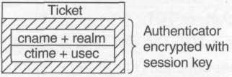
Figure 7.10 The Kerberos authenticator

Here's how a server (Bob, say) validates a ticket/authenticator pair from Alice.

- Bob decrypts the ticket with his master key, thus discovering the buried session key.
- Bob uses the session key to decrypt the authenticator sent with the ticket.
- Bob compares the client name in the authenticator with the client name in the ticket, rejecting the request if they don't match.
- Bob takes the difference between the timestamp in the authenticator and the time on his machine, moving on to step 7 if the difference is within the allowable clock skew (an allowable clock skew of five minutes is typical).
- If step 4 failed, Bob sends Alice the current (universal coordinated) time according to Bob's clock. This is simply a less efficient, nonce-based way to prove knowledge of the session key that kicks in if Alice's clock is not well synchronized.
- Alice sends another authenticator using the corrected time.
- Bob compares the timestamp in the authenticator with a list of recently received authenticators to verify that this is not a replay (this list is known as the replay cache), rejecting the request if a matching timestamp is found.
- Bob updates his replay cache by adding this new timestamp and deleting any existing timestamps that have grown stale.

Bob has now developed trust in Alice's identity and has discovered a session key that he and Alice can use to authenticate data that they send to one another.
As you can see, machines involved in Kerberos authentication rely on a common time source. Out-of-synch clocks can cause extra round-trips in a Kerberos-based system. It can also paralyze systems that don't implement a fallback nonce-based authentication mechanism as described in steps 5 and 6. I once tried changing a workstation clock on an early beta of Windows 2000 (which didn't implement this) and the system melted down fast.

The Second Subprotocol: KRB_TGS_REQ/REP
When Alice obtained a ticket for her KDC, it was only so that she could later go back to the KDC (proving her identity with her KDC ticket and its associated session key) and obtain tickets for servers on the network that hold secured resources that she needs. Getting to those resources is what Alice really cares about. Fetching that initial ticket was just a required detail that provided Alice entry to the Ticket Granting Service. That initial ticket is thus often referred to as a ticket-granting ticket, or TGT.
Now that Alice has a TGT, she can send it to the KDC any time she needs to obtain tickets for other principals in the same realm. Let's say that she arrived at work at 9:00 a.m. (and gets her TGT at that point) and then suddenly at 11:30 a.m. a client program she was running decides to make an authenticated COM call to a server running on some other machine on the network (for now, let's assume that the server process is running as a principal named Bob, who is from the same realm as Alice). The Kerberos SSP in the client process sends a request to the KDC on Alice's behalf (one that looks remarkably similar to the one we just saw) requesting a ticket for Bob. This is the Ticket Granting Service (TGS) request and reply, thus the name of the messages (see Figure 7.11).

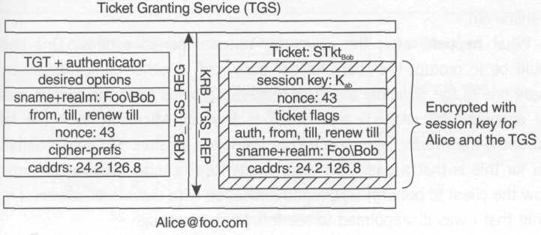
Figure 7.11 The KRB_TGS_REQ and KRB_TGS_REP messages

In this case, the slot for preauthentication data is filled with Alice's TGT/authenticator pair, which proves her identity to the KDC. Alice is requesting a ticket for Bob. Can you see anything else that's different about this pair of messages compared with the KRB_AS_REQ/REP messages?
What you may have noticed is that the reply is not encrypted with Alice's master key; rather, it is encrypted with the session key that Alice obtained earlier for use with the KDC. If it were encrypted with Alice's master key, then that key would have to be available to the Kerberos SSP on Alice's machine not only at 9:00 a.m. when she first appeared on the machine and the first subprotocol was executed, but also now at 11:30 a.m. when the ticket request for Bob is satisfied. By encrypting the data with the session key, the system ensures that the only things that AlicesMachine needs to cache on Alice's behalf are her ticket/session key pairs, not her master key. Those session keys are only good for use with their associated tickets, and tickets expire each night when Alice goes home.
It's really quite elegant, unless Alice decides to work a double shift. If she hasn't yet acquired all the tickets she needs for the night, at some point a KRB_TGT_REQ message will fail miserably due to TGT expiration. What should the system do to prevent this?
It turns out that Windows 2000 normally requests a renewable TGT that the system can continue to revalidate over and over again (until the renew-till time in the ticket). Looking at a network sniff of the unencrypted KRB_AS_REQ from a Windows 2000 Server (build 2195), it's clear that the client does indeed request a renewable TGT (and a look in the ticket cache verifies that the KDC does in fact issue one). The Kerberos Policy settings (stored in the directory service and accessible via the Group Policy snap-in) include the following properties:

Maximum lifetime for user ticket = 10 hours
Maximum lifetime for user ticket renewal = 7 days

These numbers were taken from my own installation of Windows 2000 Server (build 2195). The term user ticket is an administrator-friendly way of saying TGT. You'll also see the term service ticket. This represents any ticket that's not a TGT (the ticket for Bob that Alice just requested is considered a service ticket, for instance).
What happens after the seven-day renewal period expires? One choice would be to prompt the client for her password. Another choice would be to ignore one of the principal tenets of modern Kerberos (that the client's master key shouldn't be cached) and cache it anyway. Microsoft took the latter approach; the master key is cached in the logon session. My only rationalization for this is that a password hash needs to be cached anyway in order to allow the client to perform NTLM authentication with downlevel servers. I must admit that I was disappointed to see this behavior though.

The Third Subprotocol: KRB_AP_REQ/REP
The first two subprotocols are really concrete. The client SSP simply forms messages exactly as the Kerberos spec requires, sends them to port 88 of the closest KDC in the client's realm, and gets a reply formatted exactly as specified in RFC 1510. The third subprotocol turns out to be just a small part of a larger conversation that occurs between the client and server when the client wants to establish an authenticated connection with the server. This means that the application (AP) request and reply are piggybacked on top of whatever protocol the client and server happen to be using to get their real work done: raw TCP/UDP, SMB, RPC, or DCOM, for instance. Regardless of the communication protocol, however, the contents of the embedded Kerberos messages are always the same (see Figure 7.12).

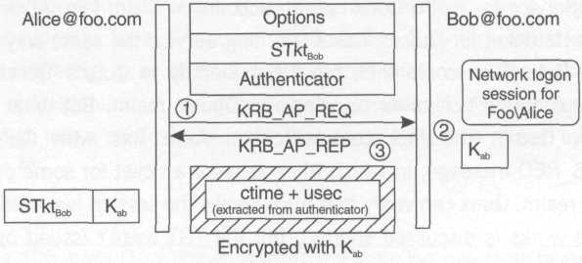
Figure 7.12 The KRB_AP_REQ and KRB_AP_REP messages

Because all the hard work has already been done by the KDC (resulting in a ticket), the application protocol is really quite simple. In fact, the reply is entirely optional and is only used if the client wishes to authenticate the server.
The options field in the KRB_AP_REQ message indicates (among other things) whether the client wishes mutual authentication, in which case the server is required to send a KRB_AP_REP message embedded in the reply. The rest of the request message consists of a ticket/authenticator pair that proves the client's identity and gives the server a copy of the session key.
To prove his identity to the client (Alice), the server (Bob) must decrypt the client's authenticator with the session key, extract the timestamp found there, reencrypt it with the session key, and send this back to the client (KRB_AP_REP). If the client requested mutual authentication, she will be expecting to receive the same timestamp she sent in the authenticator; by decrypting the same timestamp from the reply, she concludes that the sender knows the session key (by virtue of being able to decrypt the ticket), and she can feel confident that she now shares a session key with her intended target principal.

Cross-Realm Authentication and the Path of Trust
Kerberos supports cross-realm authentication, as does NTLM; however, the design of Kerberos makes transitive trust relationships between authorities feasible.
Recall what happens when Alice authenticates with another principal (Bob) in her own realm (Foo). Alice performs the first subprotocol with Foo, getting a ticket to Foo's Ticket Granting Service. She then returns this ticket to Foo via the second subprotocol, requesting a ticket for Bob. Foo verifies Alice's identity and issues the ticket, plus a session key for Alice and Bob to use. Alice sends this ticket (plus an authenticator to prove her identity) to Bob. Bob decrypts this ticket with his master key, verifies the authenticator, and believes that Alice is who she says she is, because the ticket says so (the ticket came from Foo, and Bob trusts that Foo verified Alice's identity before issuing the ticket).
What would happen if you replaced Bob in this example with the Ticket Granting Service for another realm (Quux, say)? In other words, if the Ticket Granting Service for realm Quux had an account in realm Foo, Alice would be able to get a ticket for Quux's Ticket Granting Service the same way she got a ticket for Bob. Alice could then prove her identity to Quux's Ticket Granting Service and obtain tickets for principals in Quux's realm. But what does this mean for Quux? The first communication Alice has with Quux is the KRB_TGS_REQ message, in which Alice asks for a ticket for some principal in the Quux realm. Quux can verify that Alice knows the session key inside the TGT (how this works is discussed shortly), but the TGT wasn't issued by Quux; it was issued by Foo. Thus Quux must trust Foo to have correctly verified Alice's identity. If Foo has been compromised, the request could actually be coming from anybody masquerading as Alice. This is the same idea as cross-domain authentication in NTLM: Authority Quux trusts authority Foo to vouch for Foo's principals.
Assuming this trust exists (Quux's administrator trusts Foo's administrator to guard the authentication service for realm Foo), physically what has to happen is that Foo needs to be able to produce a ticket (a TGT) that Quux can consume. Once again, think back to what happens when Alice gets a ticket for Bob: Foo encrypts the innards of Bob's ticket with Bob's master key (which is registered in Foo's security database). So when Alice asks Foo for a ticket to Quux, Foo encrypts this with Quux's master key that is registered in Foo's security database (recall that Quux has registered as a principal in Foo's realm). So when Quux receives Alice's KRB_TGS_REQ message, the ticket is encrypted with the shared key between Foo and Quux, and Quux can decrypt it and verify that Foo has vouched for Alice.
Now consider what happens if Alice is a principal in realm A, and Bob is a principal in realm C. Assume that C trusts B (by registering its Ticket Granting Service as a principal of B's realm), and B trusts A in the same fashion. In order for Alice to authenticate with Bob, she must follow the path of trust: Alice contacts her authority (A), getting a TGT for B. Alice then contacts B, requesting a TGT for C. Alice finally contacts C, requesting a ticket for Bob.
The neat thing about this mechanism is that once Alice is finished with all this work, her ticket cache will contain TGTs for A, B, and C, and she won't have to traverse that particular trust path again until those tickets expire. Because this mechanism is so efficient, it's very natural to implement transitive trust relationships between authorities to simplify administration in a large enterprise. Each domain in a Windows 2000 Active Directory forest is linked (directly or indirectly) to all other domains in that forest via bidirectional transitive trust relationships. If an administrator wishes to avoid cross-domain authentication into a particular domain, that domain must be moved into a separate forest.
It should now be clear what the transited realms field in a ticket represents. When Bob receives the ticket, he'll know (theoretically) every single trust path that was exercised, and if he suspects that realm B (for instance) has been compromised, he can deny Alice's request. The reason I say theoretically is that, although this information is present in the ticket, getting at it is not at all straightforward.
One question that hasn't been addressed is this: how does Alice discover the path of trust to get to Bob's realm? How does she know that she needs to go to B in order to get to C? The Kerberos spec doesn't address this in detail, but many implementations simply use the DNS hierarchy (or equivalent) to figure out where to place transitive trusts. Figure 7.13 shows an example of a DNS hierarchy encapsulated in an Active Directory forest. Each node (domain) trusts its parent, and each parent trusts each of its children. Thus the natural path of trust from xyzzy.foo.bar.com to quux.bar.com passes through foo.bar.com and bar.com.

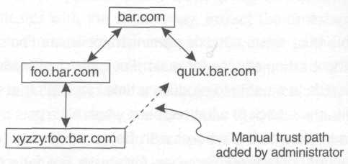
Figure 7.13 A forest of trust

Administrators can also add extra trust relationships explicitly (perhaps to improve performance or availability) between any two domains that would not normally have a trust (this can be done via the Active Directory Domains and Trusts MMC snap-in). This simply short-circuits the natural trust path, as shown in Figure 7.13.

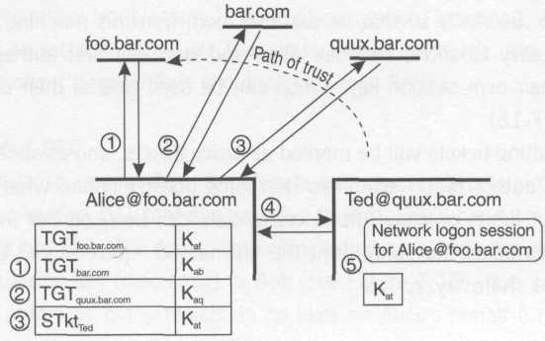
Figure 7.14 Kerberos cross-realm authentication

Figure 7.14 shows an example of cross-realm authentication. Note that once again, there must be a path of trust from the server's authority back to the authority of the client. This is a great rule of thumb for determining whether you might be having authentication problems. Ask yourself the following question: is there an unbroken path of trust from the target server principal back to the client's authority? Peek in the ticket cache to see how far along the path the client progressed before there was a problem (how to enumerate the ticket cache is discussed later in this chapter).

Delegation of Credentials in Kerberos
Unlike NTLM, in which clients must prove their identities to servers using a master secret (the password hash), Kerberos only requires a client to prove knowledge of a session-key, and that session key is associated with a ticket that has built-in limitations on its validity in space and time. Each Kerberos ticket can optionally have network addresses associated with it that limit its validity in space. Each Kerberos ticket is required to have a start and end time that limits its validity in time. Because of these limits, and because the client principal's master key is not needed at all to execute the third subprotocol, Kerberos can easily support delegation of credentials. In fact, there are two ways to do this in Kerberos: the fast and loose (but easy) way, and the conservative (but harder) way. I'll discuss both mechanisms and tell you which mechanism Microsoft chose for its implementation.

The Proxy Ticket
Let's say that Alice needs a service from Bob, but in order for Bob to do his work, he'll need to acquire secure network resources on Alice's behalf. (One classic example of this situation is a remote print spooler, which needs to have the client's credentials in order to read the client's file from the file server before printing it.)
As long as Alice knows exactly which principals Bob will need to talk to on her behalf, she can prefetch all the tickets Bob will need ahead of time. To make it concrete, let's say that Bob will need to talk to Ted and Sue, but he'll need to have those conversations while pretending to be Alice. Assuming Alice is comfortable with this, she will talk to her KDC, asking for proxy tickets for Ted and Sue. She'll have to specify Bob's network address if she wants to limit the tickets' validity in space, and she'll have to communicate the ticket/session key pairs to Bob discreetly so that he can use them from his machine. This latter problem is easy to solve, because Alice and Bob will first authenticate and exchange their own session key, which can be used to seal their conversation (see Figure 7.15).

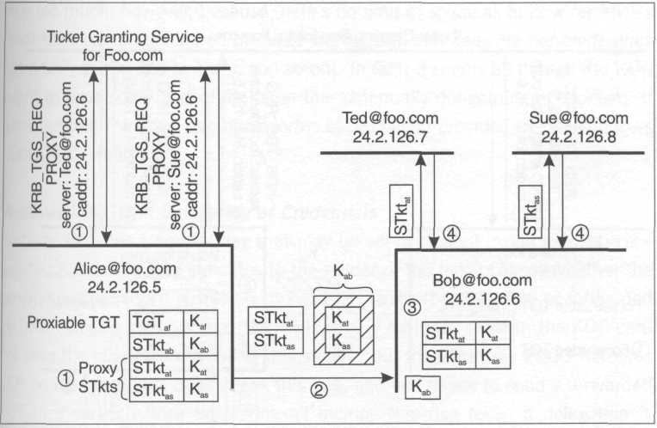
Figure 7.15 Obtaining, communicating, and using proxy tickets

The resulting tickets will be marked as proxy tickets, and as such must contain special authorization attributes (Kerberos doesn't define what these look like) that put limits on how Alice's credentials can be used (for instance: the holder of this ticket may only print the file named "quux" found on machine "baz" via the share "xyzzy").
All this configuration (setting specialized authorization attributes, knowing which principals Bob will need to talk to, knowing the network address for Bob, etc.) becomes rather troublesome in an implementation. Imagine the APIs you'd have to call to set something like this up for Alice; it's tough, but then again, delegating a client's credentials shouldn't be taken lightly.

The Forwarded TGT
The fast and loose way for Alice to delegate her credentials is to simply ask the KDC for a forwarded TGT that she can give to Bob. She'll hand off this second TGT (she got her first TGT during the initial subprotocol with her KDC) and its associated session key (discreetly) to Bob (see Figure 7.16). Bob can now use this TGT to obtain as many tickets as he likes on Alice's behalf (until the TGT expires).

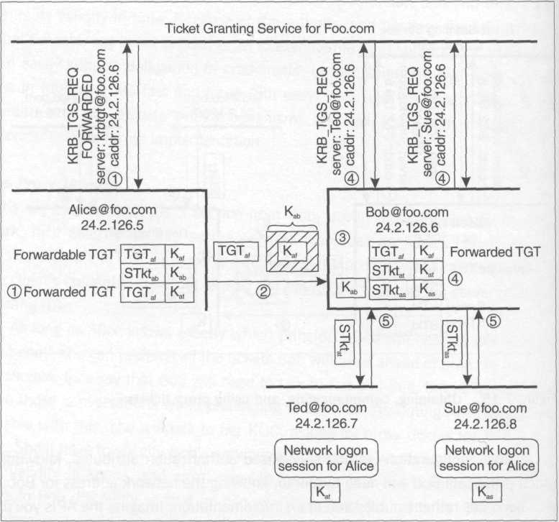
Figure 7.16. Obtaining, communicating, and using a forwarded TGT

The difference between the normal TGT that Alice uses and the forwarded TGT that she gives to Bob is twofold: the forwarded TGT has Bob's network address (or no network addresses, which means it can be used from any machine) and is marked with a flag indicating that it is a forwarded ticket. Unlike proxy tickets, a forwarded TGT does not need to have any special authorization attributes limiting its use. It can be used for any purpose.
What has Alice done in this case? She has delegated her identity to Bob for a specific period of time, and has (optionally) specified the network address from which that identity may be used. This is quite easy to implement and is the form of delegation supported by Windows 2000. You should avoid relying on it too much, however, because there's no limit in space as to how far Alice's credentials can be delegated (in other words, Bob can delegate her credentials again to Ted, and Ted to Mary, and so on). In fact, it seems as though the KDC ought to have some sort of limits on this potentially dangerous mechanism. It turns out that there are two basic forms of protection provided by the Windows 2000 KDC – read on.

Windows 2000 and Delegation of Credentials
Kerberos includes a special flag that may be set or cleared inside a ticket: ok-as-delegate. This indicates to the holder of the ticket (Alice) whether the server principal (Bob) is trusted by his KDC to use proxy tickets or forwarded TGTs to delegate client credentials. This is only a hint to a client; the KDC cannot stop the client from ignoring this setting, but the Windows 2000 Kerberos SSP on the client side does check this flag, and will refuse to send a forwarded TGT to a server whose ticket doesn't include this flag (even if delegation is requested programmatically via the impersonation level).
In Windows 2000, you can control whether a server's ticket will contain this flag on a per-principal basis. For user accounts, you must check the "Account is trusted for delegation" checkbox, and for computer accounts, you must check the "Trust computer for delegation" checkbox to enable this. By default no accounts are trusted for delegation, except for domain controllers; machine accounts for domain controllers are trusted for delegation by default. In Windows 2000, the first time Alice authenticates with a server whose ticket is marked ok-as-delegate, the system attempts to obtain a forwarded TGT. This second TGT can then be sent to the server to enable delegation. An administrator can instruct the KDC not to issue a forwardable TGT to a particular client in the first place (thus no forwarded TGTs will be issued to that client, disallowing the client from delegating his or her credentials). The way to do this is to check the "Account is sensitive and may not be delegated" checkbox in the directory service properties for the client's account.

Some Notes on Ticket Expiration
What exactly does an eight-hour ticket lifetime really mean? Does it mean that just before the eighth hour, a TGT can be used to obtain a new ticket that will last another eight hours? The answer is no. Any ticket that the KDC produces is required (by RFC 1510) to limit the end time to that specified in the TGT (there are other limitations as well that can be set via administrative policy). So if Alice's TGT expires at 17:00 and it's now 16:30, any tickets she obtains using that TGT will only be valid until 17:00.
Also remember that during the KRB_AP_REQ/REP handshake, the server obtains the client's global authorization attributes (groups) from the ticket. Thus if the client's ticket is seven hours old, those authorization attributes are also seven hours old. It may be necessary to have the client flush his or her ticket cache and get a new server ticket if these attributes need to be refreshed. It turns out that there is even a documented way of doing this.
Along this line of thought, here's an interesting question. What happens when the administrator of the Foo domain disables Alice's account (by checking the "Account is disabled" box)? If Alice has already obtained a TGT for Foo and a ticket for Bob, she can reauthenticate with Bob as many times as she likes (using the same ticket) until the ticket expires. But what if Alice attempts to acquire a new ticket, perhaps for some other server principal? When Alice contacts the Ticket Granting Service on Foo, presents her TGT, and requests another ticket, the TGS at Foo has full knowledge that Alice's account is disabled, and yet it will continue to issue new tickets to Alice. This troubled me at first, until I postulated what would happen during cross-domain authentication. Assume that Alice had previously obtained a TGT for authority Bar from Foo (this assumes that Bar trusts Foo). Unlike Foo, Bar has no idea that Alice's account is disabled, and will continue to issue new tickets to Alice as long as her TGT is valid. With this in mind, Foo's behavior is reasonable and consistent. All this comes to an end once Alice's original TGT from Foo (specifically, from the Authentication Service at Foo) expires. When the system attempts to automatically renew Alice's TGT, the Authentication Service will reject the request.

Managing the Kerberos Ticket Cache
Windows 2000 maintains an individual ticket cache for each logon session, and there are a few things you can do programmatically to manipulate the cache for your own logon session (or for someone else's if you are running in the TCB). The function LsaCallAuthenticationPackage allows you to make several different types of requests to the Kerberos authentication package, including enumerating the tickets in a ticket cache, requesting new tickets, and purging the cache.

NTSTATUS LsaCallAuthenticationPackage(
HANDLE LsaHandle, // in
ULONG AuthenticationPackage, // in
PVOID ProtocolSubmitBuffer, // in
ULONG SubmitBufferLength, // in
PVOID* ProtocolReturnBuffer, // out
PULONG ReturnBufferLength, // out
PNTSTATUS ProtocolStatus); // out

This function is really easy to use; you'll first need to connect to the LSA and look up the Kerberos authentication package index (I'll demonstrate this shortly), but after that, the rest of the parameters to this function represent a way to make any number of requests and get a corresponding reply by filling out a request structure and getting back a response structure. If you successfully contact the target authentication package, the return value from this function will be 0, indicating success, and the ProtocolStatus parameter will indicate the actual return value from the authentication package.
Before you can call this function, you'll need to connect to the LSA and obtain an authentication package index:

NTSTATUS LsaConnectUntrusted(
PHANDLE LsaHandle); // out

NTSTATUS LsaLookupAuthenticationPackage(
HANDLE LsaHandle, // in
PLSA_STRING PackageName, // in
PULONG AuthenticationPackage); // out

#define MICROSOFT_KERBEROS_A "Kerberos"

The first function is the normal way to connect to the LSA. "Untrusted" simply means that you're not necessarily part of the TCB. You'll still be able to use this handle to manipulate the ticket cache for your own logon session, just not anybody else's.
The second function is simply another hoop that you have to jump through in order to talk to the Kerberos authentication package. The manifest constant you'll need to use to initialize PackageName is listed (a helper function for initializing the lsa_string data structure is shown in the appendix). After calling this function, you'll have the authentication package index you need to invoke LsaCallAuthenticationPackage.
To enumerate the contents of the ticket cache, you'll use the following two data structures:

typedef struct _KERB_QUERY_TKT_CACHE_REQUEST
{
KERB_PROTOCOL_MESSAGE_TYPE MessageType,
LUID Logonld; // optional
} KERB_QUERY_TKT_CACHE_REQUEST;

typedef struct _KERB_QUERY_TKT_CACHE_RESPONSE
{
KERB_PROTOCOL_MESSAGE_TYPE MessageType;
ULONG CountOfTickets;
KERB_TICKET_CACHE_INFO Tickets[ANYSIZE_ARRAY];
} KERB_QUERY_TKT_CACHE_RESPONSE;

The MessageType of the request should be set to KerbQueryTicketCacheMessage, and the LogonId field should be set to 0 to indicate that you'd like to browse the ticket cache associated with your thread's current logon session. The response is basically a counted array of data structures, each of which tells you a little bit about the ticket being enumerated:

typedef struct _KERB_TICKET_CACHE_INFO
{
UNICODE_STRING ServerName;
UNICODE_STRING RealmName;
LARGE_INTEGER StartTime;
LARGE_INTEGER EndTime;
LARGE_INTEGER RenewTime;
LONG EncryptionType;
ULONG TicketFlags; // from RFC 1510
} KERB_TICKET_CACHE_INFO;

Visit my Web site for a sample program (tktview.exe) that enumerates and prints information about all the tickets in your ticket cache using these functions.
Purging your ticket cache is also quite straightforward, and is simple enough to be shown here as an example. You'll still use the same functions as before to make the call, but you'll specify a different message structure:

typedef struct _KERB_PURGE_TKT_CACHE_REQUEST
{
KERB_PROTOCOL_MESSAGE_TYPE MessageType;
LUID LogonId; // optional
UNICODE_STRING ServerName;
UNICODE_STRING RealmName;
} KERB_PURGE_TKT_CACHE_REQUEST;

Once again, if you're running in the TCB, you can purge the ticket cache for any logon session. If you're not, you must set the LogonId field to 0 to indicate that you'd like to purge the ticket cache for the logon session of the calling thread. (The following example relies on a couple of helper functions that are provided at my web site.)

void _purgeTicketCache()
{
// connect to the LSA (doesn't require TCB) HANDLE hLSA;
NTSTATUS s = LsaConnectUntrusted(&hLSA);
if (s) _lsaErr(L"LsaConnectUntrusted", s);

// look up the index for the Kerb authentication pkg
LSA_STRING sPackage;
_initString(sPackage, MICROSOFT_KERBEROS_NAME_A);

ULONG nAuthnPkg;
s = LsaLookupAuthenticationPackage(hLSA, &sPackage, &nAuthnPkg);
if (s) _lsaErr(L"LsaLookupAuthenticationPackage", s);

// set up the request message KERB_PURGE_TKT_CACHE_REQUEST request;
ZeroMemory(&request, sizeof request);
request.MessageType = KerbPurgeTicketCacheMessage;

// make the call
NTSTATUS sPkg;
s = LsaCallAuthenticationPackage(hLSA, nAuthnPkg, &request,
sizeof(request), 0, 0, &sPkg);
if (s) _lsaErr(L"LsaCallAuthenticationPackage", s);

// figure out what actually happened
switch (sPkg)
{
case 0:
wprintf(L"Successfully purged ticket cache.\n");
break;
case SEC_E_NO_CREDENTIALS:
wprintf(L"Ticket cache was already empty.\n");
break;
default:
_lsaErr(L"KerbPurgeTicketCacheMessage", sPkg);
break;
}
}

Why might you want to purge your ticket cache? Well, although a ticket cache is great from the perspective of making authentication efficient, it also can lead to stale security contexts. When Alice sends her ticket to Bob, that ticket contains Alice's authorization attributes (group SIDs) at the time she obtained the ticket (which means this information could be several hours old). Alice can easily fix this by purging her ticket cache, which will force her SSP to obtain fresh tickets on her behalf the next time she authenticates with Bob. Fortunately, authorization attributes don't change that often, but if you run into a situation in which you've been recently added to a group and yet you are not being granted the access you now deserve to a remote resource, remember this tip.

Benefits and Drawbacks of Kerberos
The benefits of Kerberos are as follows:

- It is fully documented (RFC 1510).
- It is built in to Windows 2000.
- Authentication results in the exchange of a session key.
- Kerberos supports the use of centralized authorities.
- It supports cross-domain authentication.
- It supports mutual authentication.
- It supports delegation of credentials.
- Ticket caching reduces round-trips, making the protocol less expensive and less sensitive to network outages.
- Ticket validity is limited in space and time.
- Because clients cache state (via tickets), the KDC can remain stateless across the three subprotocols (think load balancing and redundancy).
- According to RFC 1510, the client's master key may be forgotten after the first subprotocol ends, but Windows 2000 doesn't follow this particular suggestion in order to give the user a more satisfying experience (that is, until her master key is stolen).

Kerberos has the following drawbacks:

- Clocks must be synchronized (although the added support for slightly out-of-skew clocks in Windows 2000 really means that clocks should be closely synchronized for optimal performance).
- The client and server must be connected to each other (the protocol does not support disconnected operation such as authentication of MSMQ messages).
- Kerberos requires the use of a centralized authority. (If you use local accounts, even Windows 2000 falls back to using NTLM.)
- Kerberos v5 uses ASN.1 DER encoding, which is pretty obscure (part of the legacy of OSI); be happy you get to use Microsoft's implementation on Windows 2000 and you don't have to write your own.
- Authorization attributes in tickets may become stale and need refreshing.

SSPI
Consider for a moment the vast differences between the NTLM and Kerberos authentication protocols (see Figure 7.17). In NTLM, there is communication between client and server, followed by communication between the server machine and its authority. In Kerberos, on the other hand, there is communication between the client and his or her authority, followed by communication between client and server. In NTLM, there is no intrinsic client-side or server-side caching, so each client authentication request causes the server to communicate with its authority. In Kerberos, if a valid ticket exists in the cache, the client may not even need to talk to his or her authority at all.

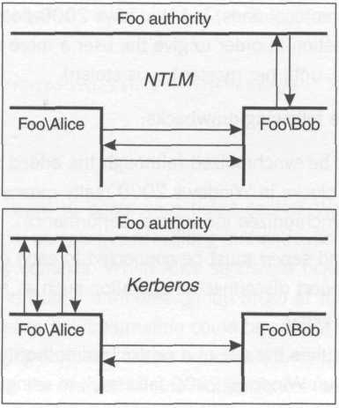
Figure 7.17 Comparing NTLM and Kerberos from a 10,000-foot vantage point

With all these differences, what do these protocols have in common? They ultimately result in a logon session for the client on the server machine. Both the client and server always discover a session key, and this key can be used to sign or seal messages passed between them. RFCs 1508 and 1509 describe an interface called the Generic Security Service API (GSSAPI) that abstracts the commonalities between most authentication protocols and hides the implementation details. Microsoft's version of this interface is known as the Security Service Provider Interface (SSPI). This is the abstract interface to all those SSPs that I've been alluding to throughout the chapter.
The idea behind GSSAPI and SSPI is that clients and servers want to have secure conversations over lots of different communication protocols: raw sockets, RPC, Java RMI, DCOM, CORBA, and so on. Rather than having each individual communication protocol tie itself closely to one particular network authentication protocol, it becomes easier to mix and match communication and authentication protocols by simply leaving space in the network packets to hold an opaque token generated by a security service provider. GSSAPI and SSPI thus define several functions that a communication subsystem should call to allow the selected SSP (NTLM or Kerberos, for instance) to do its work. Because the communication subsystem is only worried about enabling a network conversation between client and server (and knows nothing of authorities), it can easily transport opaque tokens back and forth between the client-side SSP and the server-side SSP, but any communication to a client or server's authority is the SSP's business.
Let's make this concrete by describing the fundamental methods exposed by SSPI. This first set of functions is used to establish authentication and exchange a session key:

- QuerySecurityPackageInfo Allows the communication subsystem to ask the SSP to describe itself; this includes capabilities such as sealing and signing, as well as the size of the token that the SSP will require the communication subsystem to transport between the client and server versions of the SSP
- AcquireCredentialsHandle Called on both client and server SSPs before any authentication takes place, this function allows the SSP to attach to a set of existing network credentials (this may involve making network round-trips to an authority, but that's the SSP's business; the caller doesn't care about this detail). This function also allows the caller to provide an alternate set of credentials (typically an authority/principal/password tuple).
- InitializeSecurityContext Called on the client side to give the SSP a chance to prepare an outgoing token (and perhaps process an incoming token from the server-side SSP). The NTLM SSP, for instance, will prepare a Negotiate message the first time the client-side communication subsystem calls this function. The Kerberos SSP, on the other hand, will look up a ticket for the target server principal and prepare a KRB_AP_REQ message. (If no ticket exists, the Kerberos SSP will first synchronously send a KRB_TGS_REQ message to the client's KDC and wait for the response in order to get that ticket.)

Often this function will be called more than once. Because NTLM requires a three-way handshake, this function will be called to generate the Negotiate token. After the communication subsystem sends this token and receives a Challenge token, it will call this function a second time, giving the client-side SSP a chance to process the Challenge token and produce an Authenticate token to send back to the server-side SSP The return value from this function indicates to the caller whether the SSP expects another round of token exchanges or whether authentication is complete (or whether it failed, of course). For the Kerberos SSP if mutual authentication is being used, this function will need to be called a second time to process the incoming KRB_AP_REP message that authenticates the server to the client.

- AcceptSecurityContext Called on the server side to give the SSP a chance to process the incoming token from the client-side SSP (and perhaps produce an outgoing token to send back to the client). For NTLM, this allows the SSP to process the Negotiate token and produce the Challenge token. On the second pass, the Response token is accepted (and perhaps passed through to the server machine's authority). For Kerberos, this allows the SSP to process the KRB_AP_REQ token and produce (if required) a KRB_AP_REP token. As with its client-side sibling, the return value of this function tells the server-side communication subsystem whether another token needs to be exchanged with the client or not (and whether or not authentication succeeded). Upon a successful final pass, this function causes the system to generate a new network logon session for the client.
- ImpersonateSecurityContext Called on the server side after authentication is complete to ask the SSP to place a token for the client's logon session on the caller's thread.
- RevertSecurityContext Called on the server side to undo the effect of a Call to ImpersonateSecurityContext.
- QuerySecurityContextToken (Windows 2000 only) Called on the server side after authentication is complete to directly retrieve a handle to the client's token. On older platforms the only way to get access to the token is to call ImpersonateSecurityContext and OpenThreadToken, followed by RevertSecurityContext, which feels a lot like eating a cheeseburger with your arm wrapped around the back of your head.

Once authentication is complete, regardless of whether NTLM or Kerberos (and generally any other supported protocol) was used, a session key has been exchanged and the client and server can use this session key to sign and seal messages. The following set of functions are used for this purpose.

- MakeSignature The communication subsystem (on either the client or server side) calls this function to ask the SSP to sign a message with the session key. The caller needs to provide room in the message for the resulting MAC. (The space required can be determined by calling QueryContextAttributes.)
- VerifySignature The communication subsystem calls this function to verify the MAC for an incoming\message using the session key.
- EncryptMessage The communication subsystem (on either the client or server side) calls this function to ask the SSP to encrypt a message with the session key. For legal purposes, this function is only supported on Windows 2000 and later service packs of Windows NT.
- DecryptMessage The communication subsystem calls this function to decrypt incoming messages using the session key. The same legal stipulation applies here as well.

Figure 7.18 Shows that InitializeSecurityContext and Accept SecurityContext are the key hooks used by SSPI to ride on top of many different network communication mechanisms. Note how the last call to AcceptSecurityContext in the case of NTLM causes the server-side SSP to perform synchronous pass-through authentication. Also note how in the case of Kerberos, the first call to InitializeSecurityContext causes the client-side SSP to look for appropriate tickets in the ticket cache; if they cannot be found (or if they've expired), the SSP goes and gets the tickets it needs from the KDC. The communication subsystem is completely unaware of this; it just keeps calling these functions and passing tokens to its peer until the SSP says it's done authenticating.

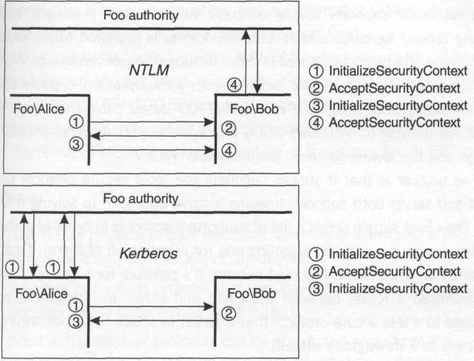
Figure 7.18 SSPI abstracts the differences between authentication protocols

The main reason I'm bothering to drill down to the level of SSPI is to give you a more intuitive feel for what authentication protocols do, and how various communication subsystems integrate with a variety of authentication protocols. When you call functions such as ImpersonateNamedPipeClient, RpcImpersonateClient, and CoImpersonateClient, you'll know that deep down, these are simply mapped to a call into the appropriate SSP, asking it to place the token (which was already discovered via an earlier authentication handshake) on your thread. Most people won't program to SSPI directly.
Another reason for mentioning SSPI is this: If you have your own custom authentication protocol, don't attempt to implement it on top of existing communication protocols such as RPC and COM; rather, implement an SSP that slips under the covers and allows you to collaborate directly with the guts of the communication subsystem. For instance, by implementing an SSP, when RPC asks you to sign an outgoing packet, you won't just be signing the payload, you'll be signing the RPC headers as well.

SPNEGO: Simple and Protected Negotiation
Windows 2000 supports several different authentication protocols, including (among others) Kerberos and NTLM. The former is preferred to the latter, but NTLM must still be implemented in order to support older versions of Windows. Here's an example of a classic problem with a multiprotocol-capable communication subsystem: Imagine a Windows 2000-based client that needs to talk to servers running on Windows 2000 and Windows NT 4. What should it do? Always use the lowest-common denominator, NTLM?
The answer is that it should negotiate the most secure protocol that the client and server both support. Imagine a naive approach to solving this problem: The client simply sends a list of supported protocols in order of preference, and the server responds by selecting one (or rejecting all of them). First of all, this adds an extra round-trip, and second, it's possible for a bad guy who has compromised a router between the client and server to change the server's response to a less secure protocol that is easier to attack (thus performing what is known as a downgrade attack).
The first problem is easy to solve: simply piggyback the first token from the client's preferred authentication protocol into the negotiation token. This way, if the server also supports the client's favorite protocol, the preferred authentication exchange is already underway (thus eliminating the extra round-trip). If the server doesn't support the first protocol in the list, it'll cost an extra round-trip to tell the client which protocol the server does support. This is a reasonable trade-off for a significant gain in interoperability.
The second problem is more difficult, but one reasonable approach is as follows: After negotiation and authentication are complete, the server echoes back to the client the original list of protocols that was presented to the server in the first negotiation token, signing this packet with the session key exchanged during authentication. This allows the client to verify that the server did indeed receive the full, unadulterated list of protocols, as opposed to a watered-down version substituted by a bad guy. (Of course, if a bad guy in the middle can instantly break the client's weakest authentication protocol during the authentication exchange, he or she would discover the session key and could alter the server's echoed list at will and recalculate its MAC, thus faking the client into believing that the negotiation was protected when it was in fact downgraded. I said the method was reasonable, not perfect.) Naturally, the negotiation can only be protected if the authentication protocol ultimately settled on supports signing messages (both NTLM and Kerberos support this).
What I've just described is known as SPNEGO, which stands for Secure and Protected Negotiation, and there is an SPNEGO SSP that does just this on Windows 2000. The SPNEGO SSP is used as the default provider in many communication subsystems (including COM) to promote maximum interoperability. As with Kerberos, SPNEGO is an open standard; it is documented in RFC 2478.

Summary
- The NTLM protocol is built into most versions of Windows. It is a simple protocol, but has lots of limitations.
- Kerberos is a robust protocol that was developed under heavy public scrutiny and is documented in RFC 1510.
- Most authentication protocols can be abstracted away from the communication subsystems that use them; GSSAPI and SSPI are examples of interfaces that allow such loose coupling.
- GSSAPI (RFCs 1508 and 1509) and SSPI expose functions that allow a communication subsystem to collaborate with a security service provider (SSP). The SSP creates and processes what look like opaque tokens to the communication subsystem, which carries them to the SSP on the other side of the wire. The two SSPs (client-side and server-side) can therefore help to piggyback an authentication protocol that authenticates the client (and often the server) and allows them to both discover a session key. Afterward, this session key can be used to sign or seal messages sent by the communication subsystem.
- SPNEGO (RFC 2478) allows GSSAPI/SSPI-based communication subsystems to negotiate the best security service provider, and makes downgrade attacks difficult for the bad guys.

Leighton (2000) has some interesting insights.
Technically, the system has cached the password hash down in her logon session, and thus Alice doesn't need to provide her password again (see Chapter 4).
This is very much a simplification of the actual algorithm, but it is detailed enough for my purposes in this book. For those who care, in NTLM v1 the hash algorithm used is MD4, and the encryption algorithm used is DES. See Leighton (2000) for more of the grungy details, including the few known details of NTLM v2, a newer version of the protocol introduced in Windows NT 4 Service Pack 4.
Note that this step will fail if Alice has not been granted the right to establish a network logon session on BobsMachine (recall the "Access this computer from network" logon right discussed in Chapter 4).
The obvious assumption is that Alice hasn't given away her session key. But this isn't much different from saying that Alice shouldn't give away her password to begin with; if Alice gives away her password, she is basically giving away her network identity. There's not much that a software-based system can do to prevent this.
If you're wondering why we don't just rely on TCP (for instance) to make sure packets arrive in order, be aware that TCP isn't designed to do this securely; a bad guy who compromises a router could easily forge TCP sequence numbers.
In classic NTLM, the session key is encrypted, but the global authorization attributes are neither encrypted nor protected with a MAC. This opens a rather nasty vulnerability because it offers the potential for a bad guy to insert extra authorization attributes into the data stream (Domain Admins being the classic example). NTLM v2 (introduced in Windows NT 4 Service Pack 4) solved this by sealing the entire payload during pass-through authentication
For an extreme example, imagine what would happen if Alice was a principal in the Z domain, and BobsMachine was a principal in the A domain. A trusts B, who trusts C, who trusts D, and so on all the way to Z. That's 25 network hops for authenticating Alice on BobsMachine (it's time-consuming and causes lots of extra network traffic). It also implies that 25 network connections must be alive and well in order for Alice to be authenticated on BobsMachine (this is very brittle). And each of these network connections would be used at every single network authentication between Alice and BobsMachine throughout the day!
Note that some servers simply reject all requests from anonymous clients. In this case, you wouldn't bother creating a security context for an anonymous client; you'd just fail the request and move on.
If the default DACL looks strange, that's because it's granting specific permissions, not generic permissions (interestingly enough, 0x01FF is equivalent to token_all_access). This is a rather nasty state of affairs for a default DACL, and thus I'd recommend that if you use ImpersonateAnonymousToken at all, you only use it to obtain a token temporarily for the purpose of performing access checks. (One hopes that Microsoft will clean up this implementation and document it at some point; it's quite useful.)
In Windows NT 4, this SID is not present in tokens for the System logon session. This oversight was corrected in Windows 2000. The upshot is that on Windows NT 4, if you want to grant access to all authenticated users and simply want to filter out the anonymous logon session, you should grant access not only to the Authenticated Users SID, but also to SYSTEM (which is technically an authenticated user; it's the operating system, for heaven's sake).
On Windows 2000, GetUserName (while impersonating a guest logon session) returns the name "Guest", but on earlier versions of Windows, it used to return the name of the principal (or at least who that principal purported to be). Also note that the token shown here is just an example; since you can physically control the groups and privileges assigned to Guest (as opposed to the anonymous logon), a Guest token might look different on your system.
This shocked the heck out me the first time I discovered this subtlety (and it always shocked students who attended my security classes at DevelopMentor). It also probably shocked a lot of administrators.
As I understand it, prior to Kerb 4 there were only two subprotocols, so my analogy doesn't hold much water from a technical standpoint, although I still like it. A third subprotocol was added in version 4 to allow implementations to avoid caching client passwords.
In Windows 2000, the AS and TGS are both provided by the domain controller; in other implementations of Kerberos, it's possible to have these services be implemented by independent daemons, potentially running on different machines. This is possible because the KDC doesn't need to maintain state across the three subprotocols (that's the client's job by caching tickets).
Of course, because the principal's authority also knows the master key, the authority can also decrypt the ticket. This is important because it's this authority who will actually create the ticket in the first place!
I say theoretically because Windows 2000 doesn't document whether it maintains such a list or how an administrator would indicate the compromise of a machine and its corresponding tickets to update the list.
All communication to the KDC on a TCP/IP network is directed to UDP or TCP port 88.
Windows 2000 allows the administrator to configure, on a per-principal basis, whether or not to require preauthentication in the KRB_AS_REQ message (this is the "Do not require Kerberos preauthentication" checkbox in Active Directory). By default, preauthentication is required.
Replay attacks can be foiled (theoretically) by maintaining a replay cache. It's not documented whether the Windows 2000 implementation does this.
Windows 2000 uses the Simple Network Time Protocol to keep clocks synchronized automatically.
Especially since I discovered this immediately after describing how wonderful RFC 1510 was (because it didn't require caching of client passwords) to a group of students at a DevelopMentor Guerrilla event.
As of this writing, I know of no documented way to disable trust relationships between domains in a forest other than separating the domains into separate forests. This has nothing to do with Kerberos; it's simply Microsoft's way of keeping things simple for administrators. Administrators need to be aware of the implications, however: each domain in a forest is trusted by all other domains in that forest to correctly authenticate its principals.
As you add new domains to an Active Directory forest, Windows 2000 creates two trust relationships: one from the parent to the child, and one from the child to the parent. So technically, although Windows 2000 uses the DNS hierarchy to figure out where to establish trusts initially, at runtime the system discovers the actual trust paths by querying the directory service. This allows the addition of short-circuited trust paths.
As mentioned before, network addresses are not intrinsically secure, but marking tickets with an expected source address helps impede the bad guys by forcing them to spoof network addresses if using stolen tickets from "safe" machines.
Technically, RFC 1510 (issued in 1993) mentions no such flag. This flag is described in the Kerberos revision Internet drafts. (As of this writing, the most recent was filed as draft-ietf-cat-kerberos-revisions-05.txt in March 2000.)
Mike Woodring at DevelopMentor pointed out this behavior, and it took some thought to rationalize what was going on.
Please note that the tokens referred to here are simply opaque byte arrays that are exchanged between client and server (for instance, the Authenticate, Challenge, and Response messages, and the KRB_AP_REQ and KRB_AP_REP messages). These are not the access tokens (kernel objects) that were discussed in depth in Chapter 4.
These functions are actually implemented by the NTLM SSP on all versions of Windows NT 4; the legal issue (as I understand it—I'm a programmer, not a lawyer) has to do with keeping random folks from developing SSPs with strong encryption algorithms that the U.S. military cannot easily break, and exporting them to countries of which the U.S. government does not approve. There are two versions of Microsoft's SSPs: a North American version (that uses reasonably strong encryption) and an "exportable" version (that uses weak encryption that can easily be broken by the U.S. government). In fact, this is the primary difference between the North American and Exportable versions of Windows. So why were these functions later documented and supported? Microsoft now has a program for signing SSPs in the same way that CryptoAPI CSPs (Cryptographic Service Providers) are signed. An independent software vendor can present a CSP/SSP to Microsoft for signing, but it's the vendor's responsibility to satisfy U.S. government export regulations.

